4999M

JERZEES Super Sweats®
Full Zip Hooded Sweatshirt

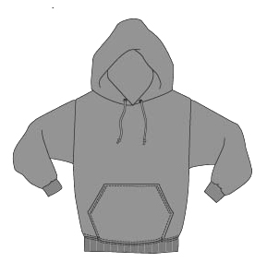

Descriptions
- 9.5-ounce, 50/50 cotton/poly NuBlend™ pill resistant fleece
- 1 x 1 ribbed cuffs and waistband with Spandex
- Kangaroo-style pockets
- Double-needle coverseam on shoulders, wristband, armholes and neck opening

Finished Garment Measurements

Size | S | M | L | XL | 2XL | 3XL
Length | 27 | 28 | 29 | 30 | 31 | 32
Width | 20 | 22 | 24 | 26 | 28 | 30
Sleeve Length | 35 | 36 | 37 | 38 | 39 | 40

